Create database Noble_win
------------------------------------------------------------------------------------------------------------------------------------

CREATE TABLE Nobel_win (
year INT,
subject VARCHAR(50),
winner VARCHAR(100),
country VARCHAR(50),
category VARCHAR(50)
);

INSERT INTO Nobel_win (year, subject, winner, country, category) VALUES
(1970, 'Physics', 'Hannes Alfven', 'Sweden', 'Scientist'),
(1970, 'Physics', 'Louis Neel', 'France', 'Scientist'),
(1970, 'Chemistry', 'Luis Federico Leloir', 'France', 'Scientist'),
(1970, 'Physiology', 'Ulf von Euler', 'Sweden', 'Scientist'),
(1970, 'Physiology', 'Bernard Katz', 'Germany', 'Scientist'),
(1970, 'Literature', 'Aleksandr Solzhenitsyn', 'Russia', 'Linguist'),
(1970, 'Economics', 'Paul Samuelson', 'USA', 'Economist'),
(1970, 'Physiology', 'Julius Axelrod', 'USA', 'Scientist'),
(1971, 'Physics', 'Dennis Gabor', 'Hungary', 'Scientist'),
(1971, 'Chemistry', 'Gerhard Herzberg', 'Germany', 'Scientist'),
(1971, 'Peace', 'Willy Brandt', 'Germany', 'Chancellor'),
(1971, 'Literature', 'Pablo Neruda', 'Chile', 'Linguist'),
(1971, 'Economics', 'Simon Kuznets', 'Russia', 'Economist'),
(1978, 'Peace', 'Anwar al-Sadat', 'Egypt', 'President'),
(1987, 'Peace', 'Menachem Begin', 'Israel', 'Prime Minister'),
(1987, 'Chemistry', 'Donald J. Cram', 'USA', 'Scientist'),
(1987, 'Chemistry', 'Jean-Marie Lehn', 'France', 'Scientist'),
(1987, 'Physiology', 'Susumu Tonegawa', 'Japan', 'Scientist'),
(1994, 'Economics', 'Reinhard Selten', 'Germany', 'Economist'),
(1994, 'Peace', 'Yitzhak Rabin', 'Israel', 'Prime Minister'),
(1987, 'Physics', 'Johannes Georg Bednorz', 'Germany', 'Scientist'),
(1987, 'Literature', 'Joseph Brodsky', 'Russia', 'Linguist'),
(1987, 'Economics', 'Robert Solow', 'USA', 'Economist'),
(1994, 'Literature', 'Kenzaburo Oe', 'Japan', 'Linguist');
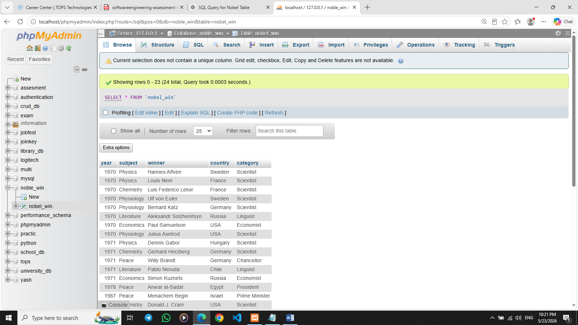

Q.1 Write sql query to find the nobel prize winners of the year 1970. Return year,subject
and winner
ANS. SELECT year, subject, winner
FROM Nobel_win
WHERE year = 1970;

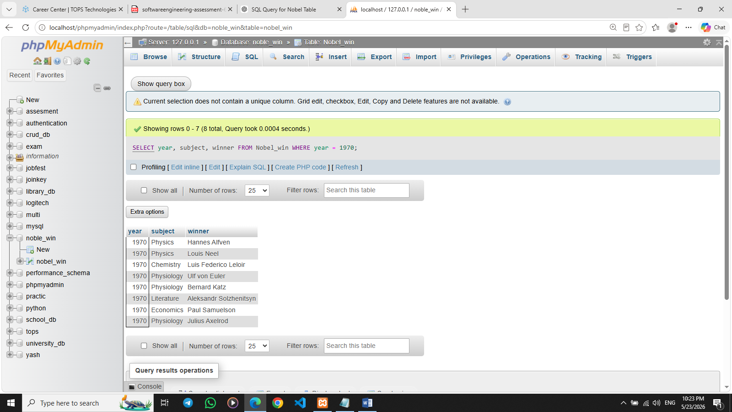

Q.2 Write sql query to find the nobel prize winners in chemistry between the years 1965 and 1975. Begin and end values are includedReturn year, subject, winner and country
ANS. SELECT year, subject, winner, country
FROM Nobel_win
WHERE subject = 'Chemistry'
AND year BETWEEN 1965 AND 1975;
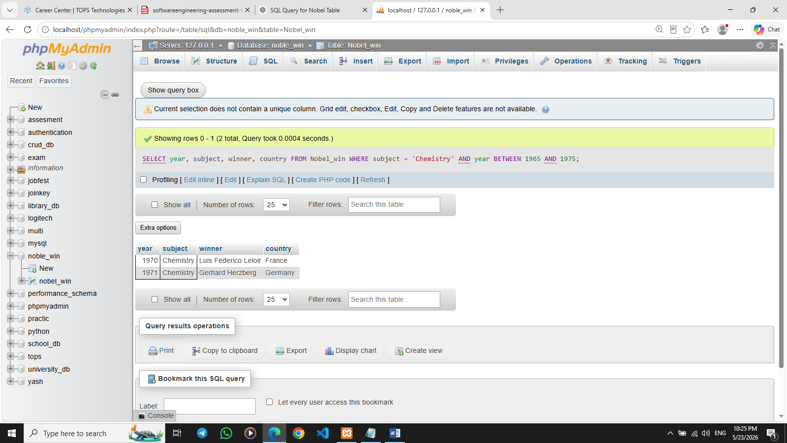

Q.3 Write sql query to retrieve the details of the winners whose first name matches with the string ‘Louis’. Return year,subject,winner,country
ANS. SELECT year, subject, winner, country
FROM Nobel_win
WHERE winner LIKE 'Louis%';
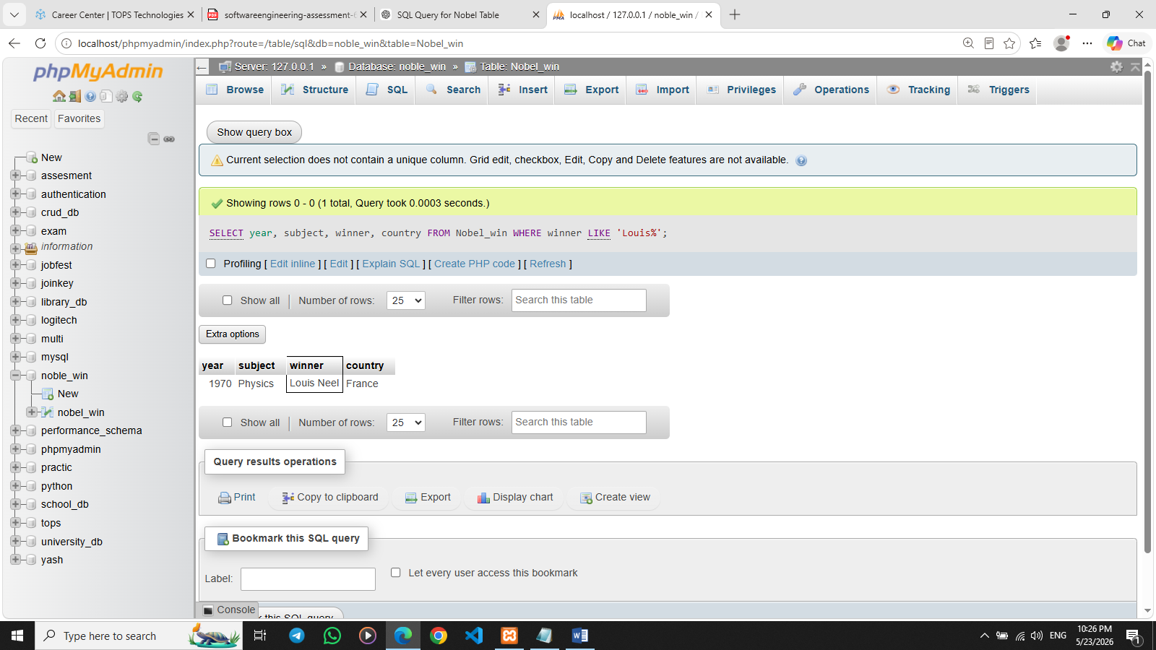

Q.4 Write sql query to find Nobel prize winners for the subject that does not begin with the letter ‘P’. Order the result by year, descending and winner in ascending
ANS. SELECT year, subject, winner
FROM Nobel_win
WHERE subject NOT LIKE 'P%'

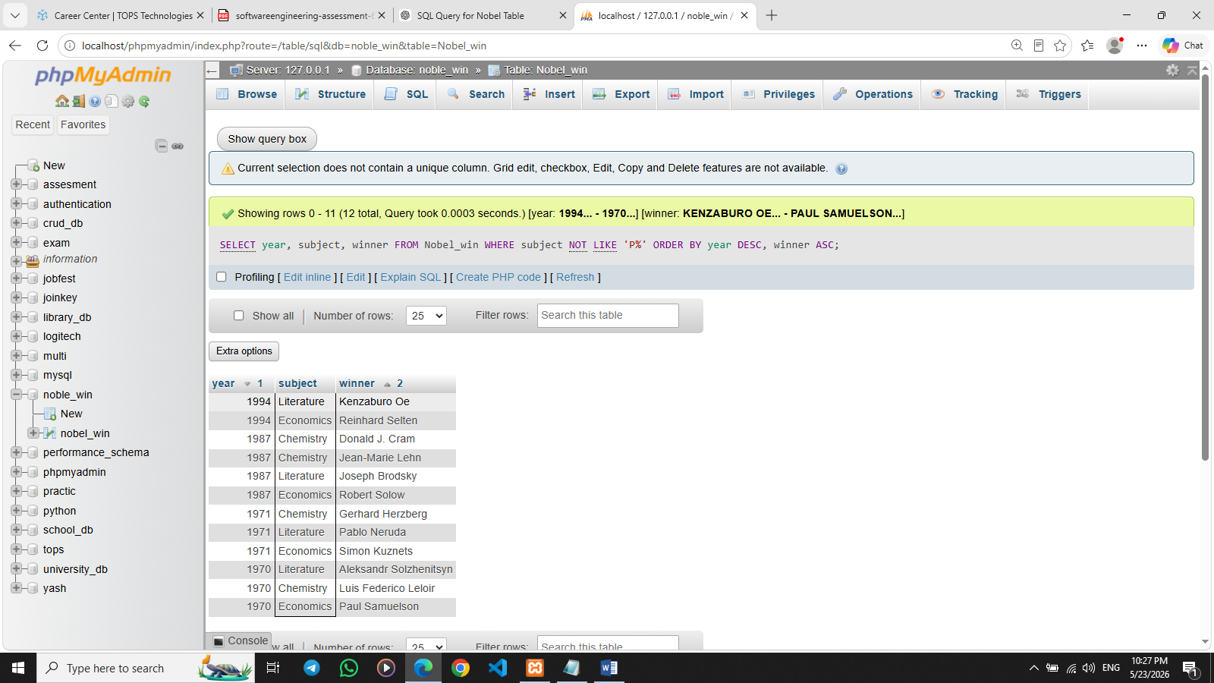

Q.5 Write sql query to find the details of 1970 Nobel prize winners. Order the result by subject, ascending except for ‘Chemistry’ and ‘Economics’ which will come at the end of the result set. Return year, subject, winner , country and category.
ANS. SELECT year, subject, winner, country, category
FROM Nobel_win
WHERE year = 1970
ORDER BY
CASE
WHEN subject IN ('Chemistry', 'Economics') THEN 1
ELSE 0
END,
subject ASC;

